Flexible Curve Spinal Measurement Protocol for Clinical Assessment of Kyphosis and Lordosis
modified from Lindsey, C (2017)
- Draw a straight line on your paper
- Patient is in standing position with back exposed, looking straight ahead (standardize if using usual, best, or relaxed posture; shoes on or off)
- Palpate and mark the center of the landmarks for C7 spinous process and L-S joint space:
  - C7 spinous process:
    - C7 spinous process (does not disappear with C-spine flexion to extension motion)
    - C6 spinous process (does disappear with C-spine flexion to extension motion)
    - T1 spinous process (does not disappear with C-spine flexion to extension motion)
  - L-S joint space (L5-S1):
    - L4-L5 (will open/close with flexion to extension motion)
    - L5-S1 (will open/close with flexion to extension motion)
    - S1-S2 (will not open/close with flexion to extension motion)
- Mold and shape the flexible ruler to the patient’s back
- Verify that the flexicurve will maintain its shape while holding ruler at one spot
- Mark the flexicurve at the level of the landmarks
- Place the flexicurve on the paper and align landmarks with the line
- Trace the curve on the side of the ruler that was touching the patient
- Transfer the landmarks from the ruler to the paper
- Measure the thoracic and lumbar, length and width in centimeters to the nearest millimeter
- Calculate the kyphotic index (TW/TL)*100
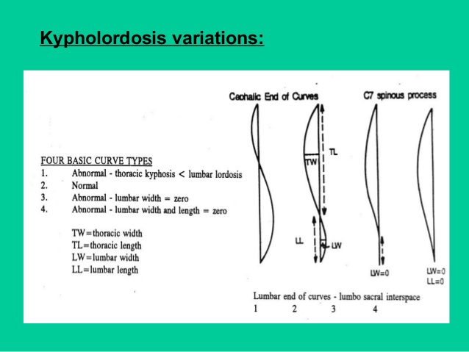

Reference:
Lindsey, C. (2007). Kypholordosis Measurement Using a Flexible Curve. Section on Geriatrics of the American Physical Therapy Association, and the Osteoporosis Special Interest Group of the Section on Geriatrics.

Blocks Method
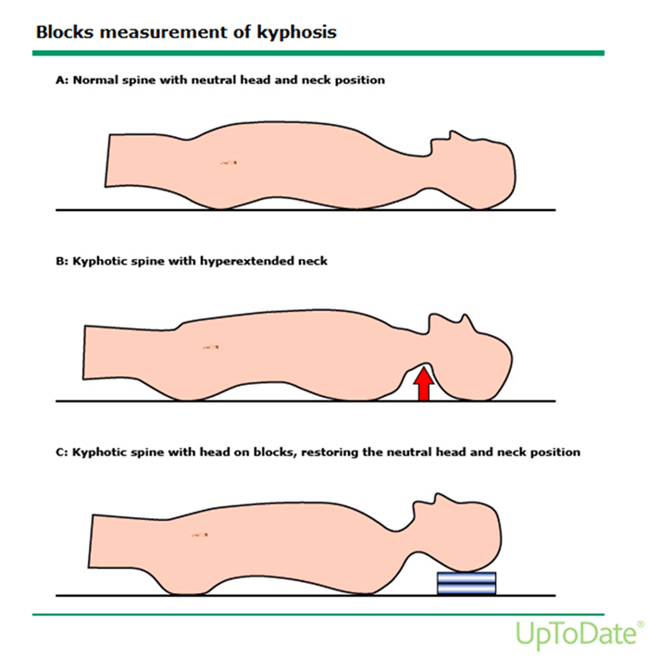

Patient lies supine on a level surface such as mat table.
Place neck and head in a neutral position.
Illustrations above:
A. Normal posture would not require blocks placed under the head to achieve neutral.
B. Hyperkyphotic posture without blocks will results in the head dropping back into extension.
C. Hyperkyphotic posture with blocks adjusted so that the neck and head are in neutral.

Neutral may be determined:
a. By observing the plane of the face as being parallel with the table.
or
b. When the patient’s gaze is directed straight up to the ceiling and the neck is neither hyperflexed nor hyperextended.
or
c. When the patient’s line of sight is perpendicular to the plane of the body.

Tragus to Wall test
Patient stands with heels and buttocks against the wall.
The head is placed as far as possible, keeping the chin horizontal.
Normally less than 15 cm

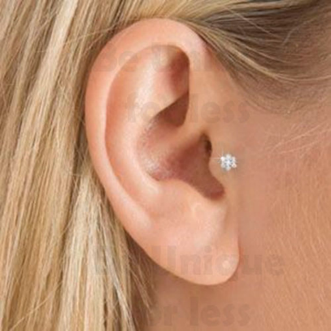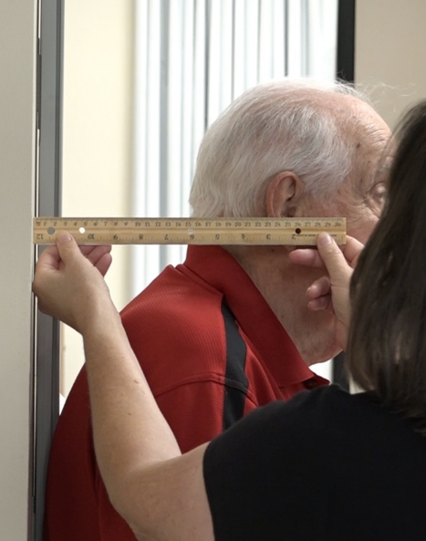

Acromion to Table test
Patient lies supine
Hands resting at sides or on abdomen
Locate the posterior lateral aspect of the acromion. Measure in cm from table to acromion.

