Texas State Round Rock Campus Location and Parking Information
Tours of the building and “Beyond the Diagnosis” art show will begin in the first floor lobby at 5:30. The CCU presentation will begin at 6:30 in room 124.

Parking Options
- Park in the Pay-to-Park lot (in black on the map) across from the Nursing Building. If you park in this lot we can sell you a parking voucher for $2, please bring cash. Walk across the mall to Willow Hall.

- Park in the purple “Perimeter” lot behind Willow Hall. Purchase a parking voucher from the Pay-to-Park machine in the lot. This will cost you $5 and you can use a credit card.
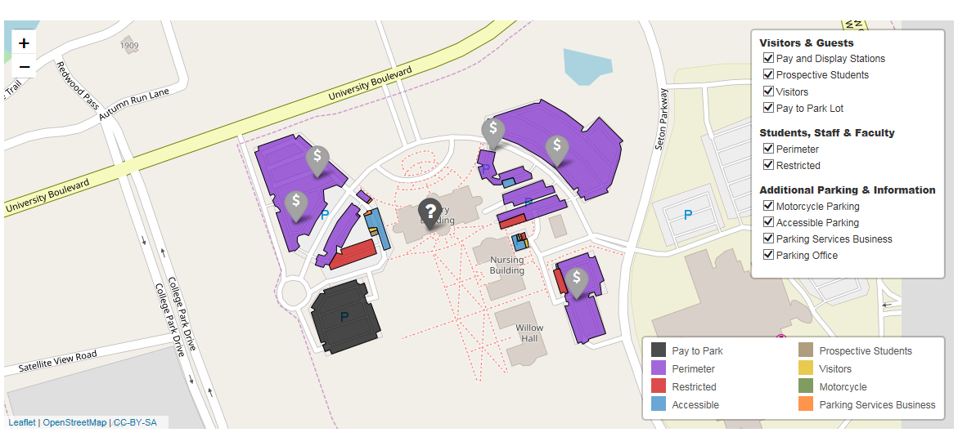

From SOUTH and CENTRAL AUSTIN using I-35:
- Start out going NORTH on I-35.
- Take EXIT #256 - SH 1431/University Blvd.
- Turn RIGHT (East) onto University Blvd.
- Keep STRAIGHT for about 2 miles.
- Texas State University, 1555 UNIVERSITY BLVD. will be on RIGHT SIDE. If you are parking in the Pay-to-Park lot ($2) turn into the main entrance. If you are paying to park in the lot behind Willow Hall, 200 Bobcat Way, ($5) turn right onto Seton Parkway and then right onto the campus.
From NORTH of ROUND ROCK area using I-35:
- Start out going SOUTH on I-35.
- Take EXIT #256 - SH 1431/University Blvd.
- Turn LEFT (East) onto University Blvd.
- Keep STRAIGHT for about 2 miles.
- Texas State University, 1555 UNIVERSITY BLVD. will be on RIGHT SIDE. If you are parking in the Pay-to-Park lot ($2) turn into the main entrance. If you are paying to park in the lot behind Willow Hall, 200 Bobcat Way, ($5) turn right onto Seton Parkway and then right onto the campus.
From Austin and I-35 using TX-130-Toll N
- On I-35 N go toward US-290 E
- Take exit #238B/HOUSTON onto US-290 E go 6.61 mi
- Take the WACO exit onto TX-130-TOLL N (Toll applies) go 18 mi
- Take exit #419/CHANDLER RD (Toll applies)
- Turn LEFT onto CHANDLER RD
- Continue on CHANDLER RD go 3.92 mi (CHANDLER RD BECOMES UNIVERSITY BLVD after the FM 1460 intersection)
- If you are parking in the Pay-to-Park lot ($2) turn LEFT into the main entrance. If you are paying to park in the lot behind Willow Hall, 200 Bobcat Way, ($5) turn LEFT onto Seton Parkway and then right onto the campus.

